

**Green University of Bangladesh**

**Department of Computer Science and Engineering (CSE)**

**Faculty of Sciences and Engineering**

**Semester: (Summer, Year:2021), B.Sc. in CSE (Day)**

**Course Title: Operating System Lab**

**Course Code: CSE_310 Section: DE (201)**

**Lab Project Name:**

**Green university account's transaction management system**

**Student Details**

|  |  |  |
| --- | --- | --- |
|  | **Name** | **ID** |
|  | Shagor Kumar Das | 201002403 |
|  | Md. Nafis Choowdhury | 201002412 |

**Submission Date**   **: 05.17.2022**

**Course Teacher’s Name**  **: Md. Jahidul Islam**

**[For Teachers use only: Don’t Write Anything inside this box]**

**Lab Project Status**

**Marks: ………………………………… Signature: .....................**

**Comments: .............................................. Date: ..............................**

Table of Contents

**Chapter 1 Introduction** 3

1.1 Introduction 3

1.2 Design Goals/Objective 3

**Chapter 2** 4

**Implementation of the Project** 4

**Chapter 3 Performance Evaluation** 14

3.1 Simulation Procedure 14

3.2 Results and Discussions 16

**Chapter 4 Conclusion** 20

4.1 Introduction 20

4.1 Limitations 20

4.2 Scope of Future Work 20

**References** 20

# 

# Chapter 1 Introduction

# 1.1 Introduction

Green university account's transaction management system is a system software that helps the authorities to keep track of every transaction made by the students for different purposes like mid-term, final examination, registration, and others.

This system is very useful and very easy to use. This system can be used as a tool for any kind of transaction or payment management system.

This system provides features like inserting records, deleting records, searching records, updating records, and displaying all the information. As it is a software-based product so it will help to remove the manual work and also will save time.

This system is fully built at the administrative end thus only the authorities grunt to access.

# 

# 1.2 Design Goals/Objective

The project goals and objectives that will be achieved after completion of this project are discussed in this subchapter. The aims and objectives are as follows:

1. Information collection for every transaction.
2. Adding new student’s transaction record to the database.
3. Find any student from the database.
4. Changing any information in any of the old record students.
5. Delete the record of any student currently in the data record.
6. View records of all students located in the record.

# 

# Chapter 2

# Implementation of the Project

We have built the very simple shell script for managing a student information data record. In this project simple features are included like make new transaction, remove a record, update a record, search a record and view all the transactions.

Step-1:

At first the program will continue until user exit manually. So first we add a while true condition. And as the only authorities are grantee to access so we put a security code with that.

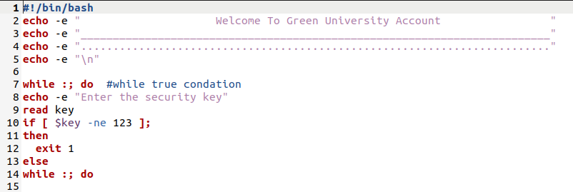

Step-2:

Code for main menu options. We use case conditional statement (Switch Case) system to access every option.

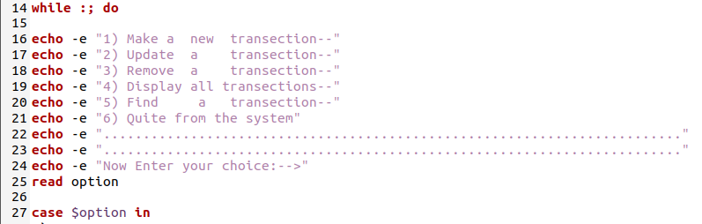

Step-3:

Here is the code for make a new transection. Here we take every necessary information and stored that inside a database named database.

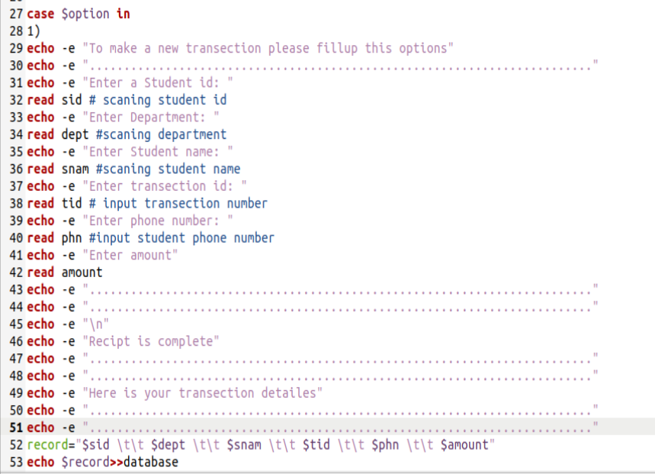

Step-4:

Here is the code for update. At first the program will confirm that the required data is exist or not. Then it will modify data according to process.

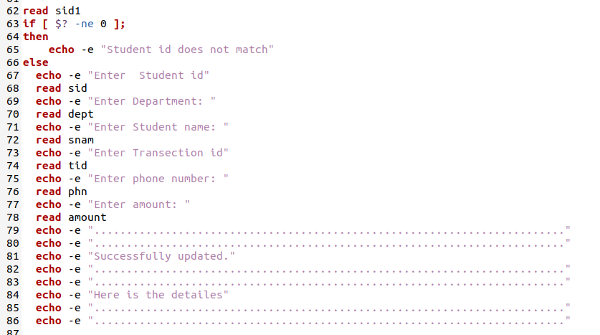

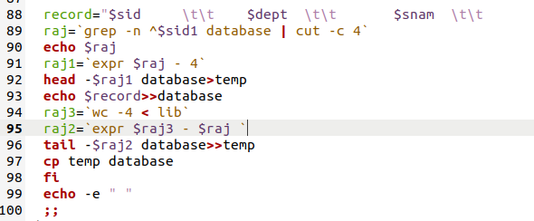

Step-5:

Here is the code for remove any information. The program will assures first if the data is exists or not. Then it will remove it according to the process. “grep” is a command-line utility for searching plain-text data sets for lines that match a regular expression.

-v, --invert-match

Invert the sense of matching, to select non-matching lines. (-v is specified by POSIX.)

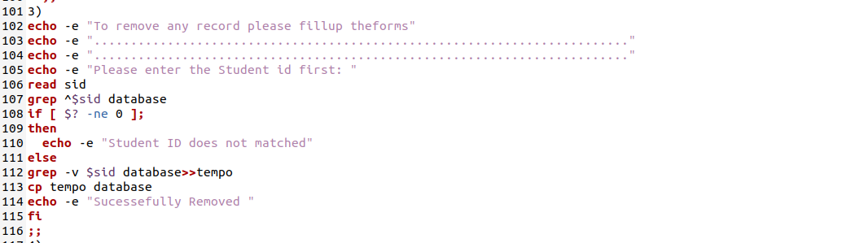

Step-6:

Here is the code for view all the information.

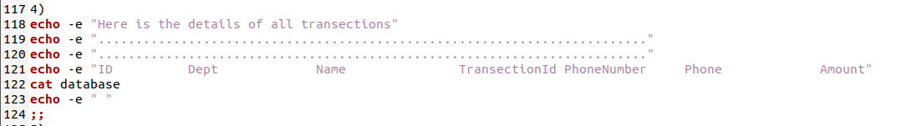

Step-7:

To search for any information this is the required portion of code.

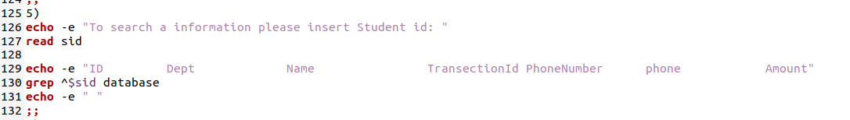

Step-8:

Here is the full source code of our project.

|  |
| --- |
| Source code |
| #!/bin/bash  echo -e " Welcome To Green University Account "  echo -e "_________________________________________________________________________"  echo -e "........................................................................."  echo -e "\n"  while :; do #while true condation  echo -e "Enter the security key"  read key  if [ $key -ne 123 ];  then  exit 1  else  while :; do  echo -e "1) Make a new transection--"  echo -e "2) Update a transection--"  echo -e "3) Remove a transection--"  echo -e "4) Display all transections--"  echo -e "5) Find a transection--"  echo -e "6) Quite from the system"  echo -e "........................................................................."  echo -e "........................................................................."  echo -e "Now Enter your choice:-->"  read option  case $option in  1)  echo -e "To make a new transection please fillup this options"  echo -e "........................................................................."  echo -e "Enter a Student id: "  read sid # scaning student id  echo -e "Enter Department: "  read dept #scaning department  echo -e "Enter Student name: "  read snam #scaning student name  echo -e "Enter transection id: "  read tid # input transection number  echo -e "Enter phone number: "  read phn #input student phone number  echo -e "Enter amount"  read amount  echo -e "........................................................................."  echo -e "........................................................................."  echo -e "\n"  echo -e "Recipt is complete"  echo -e "........................................................................."  echo -e "........................................................................."  echo -e "Here is your transection detailes"  echo -e "........................................................................."  echo -e "........................................................................."  record="$sid \t\t $dept \t\t $snam \t\t $tid \t\t $phn \t\t $amount"  echo $record>>database  echo -e " "  ;;  2)  echo -e "To modify a transection please fillup the option"  echo -e "........................................................................."  echo -e "........................................................................."  echo -e "Please enter the student id first"  read sid1  if [ $? -ne 0 ];  then  echo -e "Student id does not match"  else  echo -e "Enter Student id"  read sid  echo -e "Enter Department: "  read dept  echo -e "Enter Student name: "  read snam  echo -e "Enter Transection id"  read tid  echo -e "Enter phone number: "  read phn  echo -e "Enter amount: "  read amount  echo -e "........................................................................."  echo -e "........................................................................."  echo -e "Successfully updated."  echo -e "........................................................................."  echo -e "........................................................................."  echo -e "Here is the detailes"  echo -e "........................................................................."  echo -e "........................................................................."    record="$sid \t\t $dept \t\t $snam \t\t $tid \t\t $phn \t\t $amount"  raj=`grep -n ^$sid1 database | cut -c 4`  echo $raj  raj1=`expr $raj - 4`  head -$raj1 database>temp  echo $record>>database  raj3=`wc -4 < lib`  raj2=`expr $raj3 - $raj `  tail -$raj2 database>>temp  cp temp database  fi  echo -e " "  ;;  3)  echo -e "To remove any record please fillup theforms"  echo -e "........................................................................."  echo -e "........................................................................."  echo -e "Please enter the Student id first: "  read sid  grep ^$sid database  if [ $? -ne 0 ];  then  echo -e "Student ID does not matched"  else  grep -v $sid database>>tempo  cp tempo database  echo -e "Sucessefully Removed "  fi  ;;  4)  echo -e "Here is the details of all transections"  echo -e "........................................................................."  echo -e "........................................................................."  echo -e "ID Dept Name TransectionId PhoneNumber Phone Amount"  cat database  echo -e " "  ;;  5)  echo -e "To search a information please insert Student id: "  read sid  echo -e "ID Dept Name TransectionId PhoneNumber phone Amount"  grep ^$sid database  echo -e " "  ;;  6)  exit 1  echo -e "Quite from the program"  ;;  esac  done    #Shagor Kumar Das  fi  done |

# Chapter 3 Performance Evaluation

# 3.1 Simulation Procedure

We complete and set our full project in the VMware(Ubuntu 64 bit). The step by step process is given below.

Step 1: open VMware and login to Ubuntu.



Figure 3.1: VMware(Ubuntu 64 bit)

Step 2: Then create a bash script using terminal and some required commands.

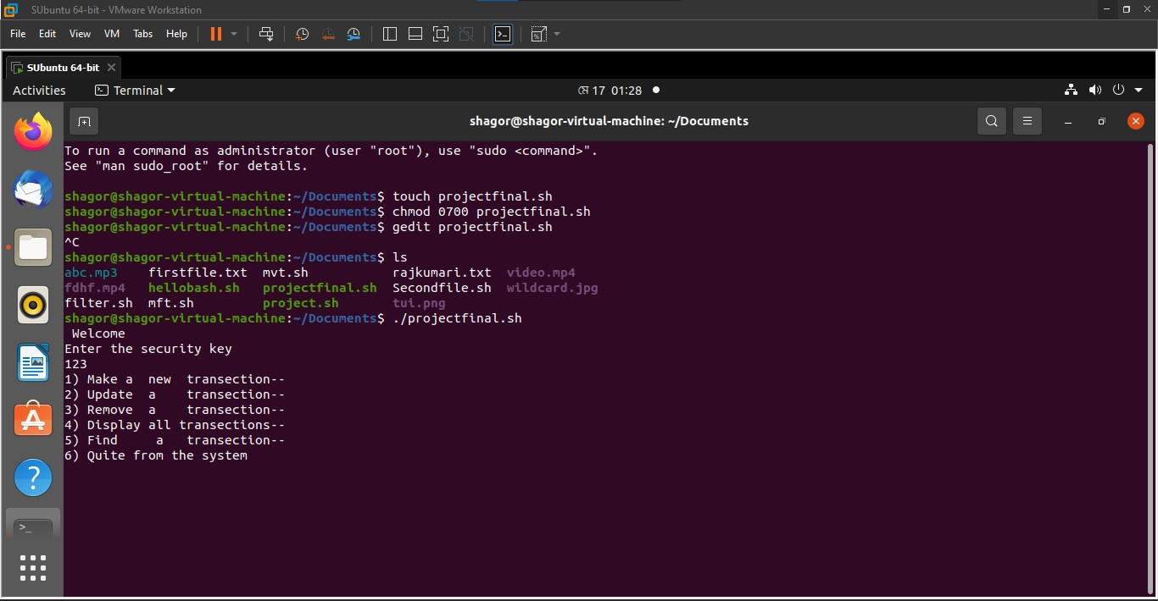

Figure 3.2: Bash script creation.

Step 3: Then we write the script inside the text file.



# 3.2 Results and Discussions

## 3.2.1 Results

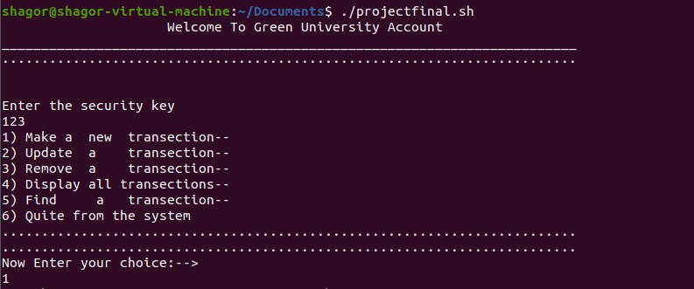

Figure: Starting view



Figure: Display Options choice

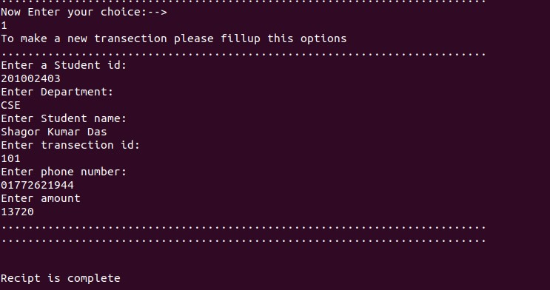

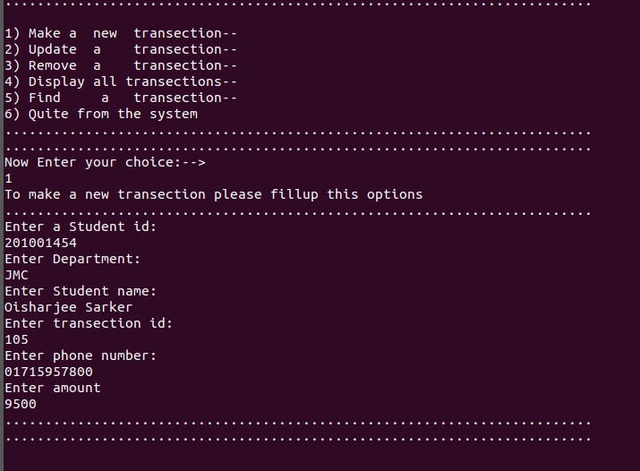

Figure: Adding a new records

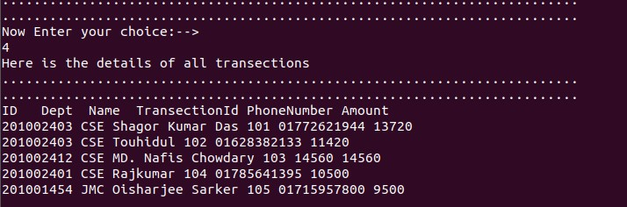

Figure: View all records

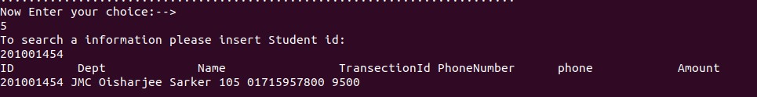

Figure: Searching for a record

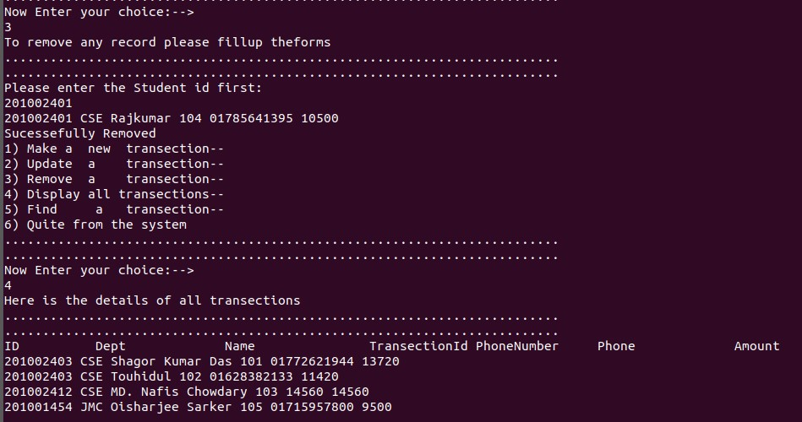

Figure: remove a record

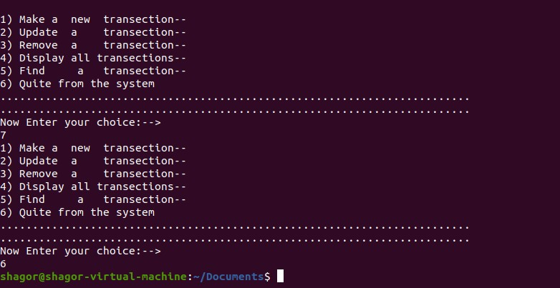

Figure 3.11: Exit the software

## 3.2.2 Analysis and Outcome

We implemented this transaction management system in Bash Script. This keep track of every transaction made by a student. As it is an automatic system and also safe so the authority can keep data in safe. It is also very easy to use so the data management will be very easy here.

# Chapter 4 Conclusion

# 4.1 Introduction

This project provides a computerized version of Transaction management system which will benefit the staff of the institutions. School, college’s staff can easily get any information related to the student’s transaction. They can add to the software, so that they can use this information later. This project will greatly reduce and simplify the work of institution’s officials.

# 4.1 Limitations

* In this student information Database, it can’t track the count of the student in the record and listed student details.
* It isn’t a user-friendly interface, so basic computer knowledge isn’t enough to access the student information Database.

# 4.2 Scope of Future Work

Through Bash Shell Scripting language, we have given a general idea of transaction management system. This project can be further developed in the future. We are giving an idea of what kind of development can be done:

There will be a system of student login and students will have various information including the date of admission and other important information. He will take all the information and keep the students aware of the main.

# References

[1]. <https://developpaper.com/implementation-of-student-achievement-management-system-by-shell-programming/>

[2] <https://www.cyberciti.biz/faq/howto-use-grep-command-in-linux-unix/>